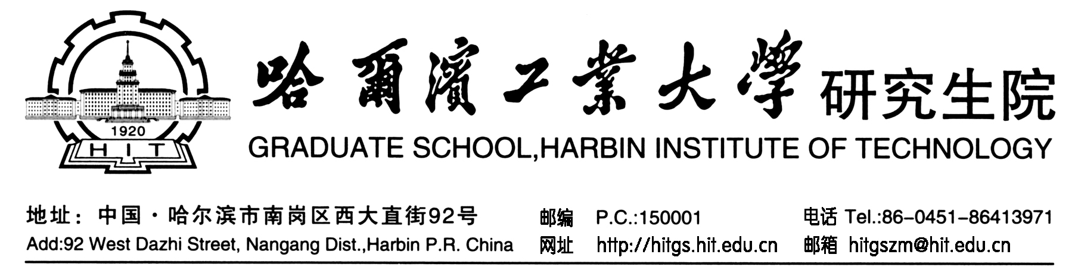

硕士研究生学业奖学金证明
Certificate of Academic Scholarship

兹证明硕士研究生 ，性别： ， 年 月 日出生，学号： 。于 年 月进入哈尔滨工业大学 学院 学科学习。第一学年学业奖学金等级为 等，第二学年学业奖学金等级为 等。

This is to certify that , male/female, student ID: , born on July 10, 1986, has been working for his/hers Master’s Degree in the School of Mechanics at Harbin Institute of Technology since September 2018, majoring in Mechanics. He/She has been awarded the First-class Scholarship for the first academic year, and the First-class Scholarship for the second academic year.

哈尔滨工业大学研究生院
The Graduate School, Harbin Institute of Technology
年 月 日
March 1, 2020

